GLM FOR T-TESTS AND ANOVA
REVIEW
Quick review of linear regression …
We measured mouse weight and mouse size; we want to learn to things from it:
- How useful is mouse weight for predicting mouse size (R-squared)
- Is the relationship due to chance ? (p-value)
Let´s see if we can apply those concepts to a t-test.
T-TEST
The goal of a t-test is to COMPARE MEANS and see if they are significantly different from each other.
In this example we are going to be comparing gene expression between control mise and mutant mise:
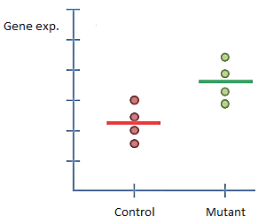
If the same method can calculate p-values for a linear regression and a t-test, then we can easily calculate p-values for more complicated situations. So now, we are going to walk through the steps for using the techniques from linear regression to do a t-test …
1st, ignore the x-axis and find the overall mean
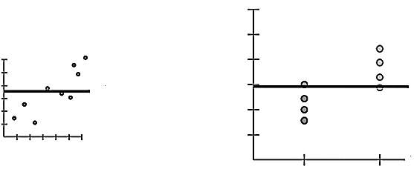
2nd, calculate the sum of squared residuals around the mean SS(mean)
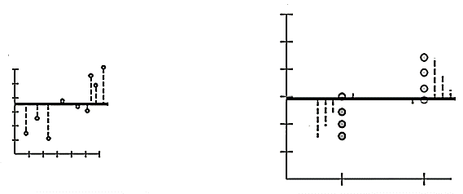
3rd, fit a line to the data
How do we do a least-squares fit to a t-test ???
  - We start by finding the least-squares fit to the control data (It turns out that the mean is the least-squares fit)
  - We do the same for the mutant data
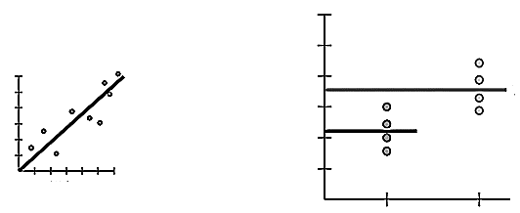
We have fit two lines to the data ! $y=3,6$ and $y=2,2$ …
Originally when we did the regression, we fit a single line to the data. However, there is a way to combine these two lines into a single equation. This will make the steps for computing $F$ the exact same for the regression and the t-test.
Keep in mind that the goal is to have a flexible way for a computer to solve this, and every other ´least-squares´ based problem, without having to create a whole new method each time.
  - We use a design matrix X combined with an abstract version of the equations to represent a ´fit´ to the data
$$X={\left[\begin{aligned}1 \\ 1 \\ 1 \\ 1 \\ 0 \\ 0 \\ 0 \\ 0\end{aligned}\begin{aligned} \\ \\ \\ \\ \end{aligned}\begin{aligned}0 \\ 0 \\ 0 \\ 0 \\ 1 \\ 1 \\ 1 \\ 1\end{aligned}\right]}_{8×2}$$
$$y=column1×2,2+column2×3,6$$
Column 1 turns the control mean on or off, and column 2 does the same for the mutant mean. In practice the role of each column is assumed, and the equation is written out like this:
$$y={mean}_{control}+{mean}_{mutant}$$
Now that we have the ´fit´ for the control and mutant data down to a single equation (plus design matrix). We can move on to calculating $F$ and the p-value.
4th, calculate the sum of squares of the residuals around the fitted line(s) SS(fit)
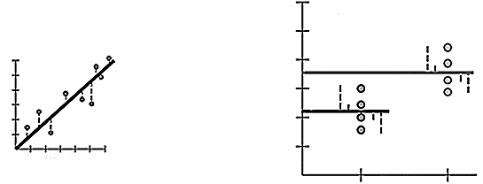
5th, now we can just plug the values in our equation for $F$…
$$F=\frac{\frac{SS\left(mean\right)-SS(fit)}{p_{fit}-p_{mean}}}{\frac{SS(fit)}{n-p_{fit}}}$$
$$p_{mean}=1$$
$$p_{fit}=2$$
… then, $F$ will lead to a p-value.
ANOVA
ANOVA tests if all 5 categories are the same.
Now let´s do an ANOVA … in this example we have control and mutant mice just as before, but we also have control and mutant mice on a funky diet and we also have heterozygote mice.

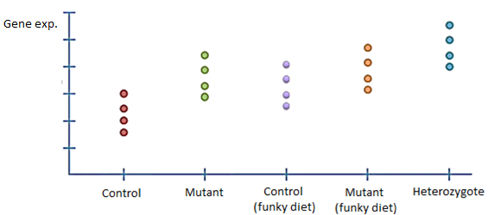
The first thing we do is to calculate the sum of squares around the mean SS(mean):
The equation for the overall mean is just $y=mean$, and that equation only has a single parameter, so $p_{mean}=1$.
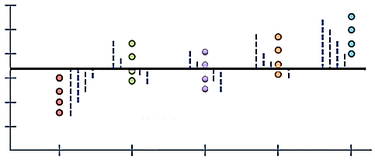
Second, we calculate the sum of squares around the fitted line(s) SS(fit):
The equation for the fitted line(s) (plus design matrix) is this …
$$y=\begin{aligned}mean_{control}+mean_{mutant}+mean_{funky control} \\ +mean_{funky mutant}+mean_{heterozygote}\end{aligned}$$
$$X={\left[\begin{aligned}1 \\ ⋮ \\ 0 \\ 0 \\ 0\end{aligned} \begin{aligned}⋮ \\ 1 \\ ⋮ \\ 0 \\ 0\end{aligned} \begin{aligned}0 \\ ⋮ \\ 1 \\ ⋮ \\ 0\end{aligned} \begin{aligned}0 \\ 0 \\ ⋮ \\ 1 \\ ⋮\end{aligned} \begin{aligned}0 \\ 0 \\ 0 \\ ⋮ \\ 1\end{aligned}\right]}_{20×5}$$
… and it has 5 parameters, therefore $p_{fit}=5$.
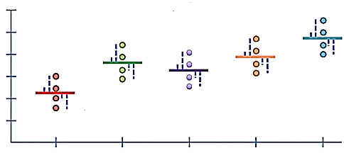
Last, we calculate $F$ …
$$F=\frac{\frac{SS\left(mean\right)-SS(fit)}{p_{fit}-p_{mean}}}{\frac{SS(fit)}{n-p_{fit}}}$$
… if we can calculate $F$, then we got a p-value!

